Different Pronunciation

🔹 What is Different Pronunciation
# Source: Chatgpt (GPT-4-turbo) at [8/1/2025]
(Also called: Heteronyms)
These are homographs—words spelled exactly the same—but pronounced differently, and have different meanings.
✅ Same spelling
❌ Different pronunciation
❌ Different meanings
This unique subtype of homographs is called heteronyms.

🧱 Key Features
# Source: Chatgpt (GPT-4-turbo) at [8/1/2025]
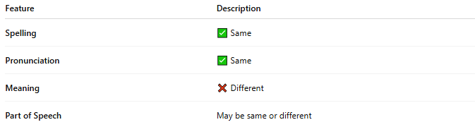
Feature | Description
Spelling | ✅ Same
Pronunciation | ❌ Different
Meaning | ❌ Different
Part of Speech | Often different
Type | Subclass of homographs = Heteronyms

📝 Examples of Homographs with Different Pronunciation (Heteronyms)
# Source: Chatgpt (GPT-4-turbo) at [8/1/2025]
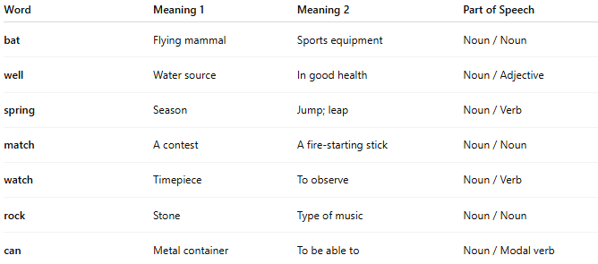
Word | Pronunciation 1 | Meaning 1 | Pronunciation 2 | Meaning 2 | Part of Speech
lead | /liːd/ (leed) | To guide | /lɛd/ (led) | A metal | Verb / Noun
wind | /wɪnd/ | Moving air | /waɪnd/ | To twist or turn | Noun / Verb
tear | /tɪə(r)/ | A drop from the eye | /teə(r)/ | To rip | Noun / Verb
row | /rəʊ/ | A line or series | /raʊ/ | A quarrel or noisy fight | Noun / Noun
read | /riːd/ (present) | To look at written words | /rɛd/ (past) | Past tense of “read” | Verb / Verb
bass | /bæs/ | A type of fish | /beɪs/ | Low musical tone or instrument | Noun / Noun
live | /lɪv/ | To be alive | /laɪv/ | Happening now; alive (adj) | Verb / Adjective

🔍 Why It Matters
# Source: Chatgpt (GPT-4-turbo) at [8/1/2025]
- Can create confusion in reading without context.
- Important in poetry, rhetoric, and wordplay.
- A clear example of why English is not purely phonetic.

🧭 Comparison Table
# Source: Chatgpt (GPT-4-turbo) at [8/1/2025]
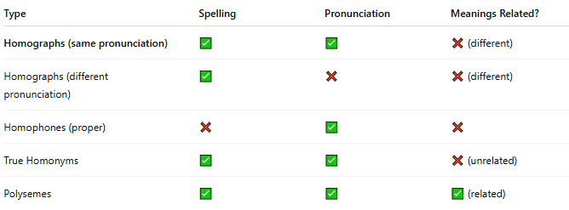
Term Type | Spelling | Pronunciation | Meaning | Example
Homographs (diff. pronunciation) | ✅ | ❌ | ❌ | wind / wind
Homographs (same pronunciation) | ✅ | ✅ | ❌ | bat / bat
Homophones | ❌ / ✅ | ✅ | ❌ | bare / bear
Capitonyms | ✅ (case) | ✅ / ❌ | ❌ | Polish / polish

